ROAD CLOSURES AND RESTRICTIONS

RACE START TIME: 09:30 ROUTE CLOSURES FROM: 06:00

Marathon Yorkshire are pleased to, once again, be working in partnership with City of York Council, Ryedale District Council, North Yorkshire County Council and East Riding of Yorkshire Council to deliver the Yorkshire Marathon including the Yorkshire 10 Mile.

In accordance with traffic authority regulations for the City of York, North Yorkshire and East Riding of Yorkshire, an order has been made prohibiting and restricting the use of certain roads and road junctions in order to facilitate the safe holding of the Yorkshire Marathon and Yorkshire 10 Mile. The events will require the closure of roads and road junctions as well as the suspension of a number of Traffic Regulation Orders between 10 :00 on Saturday 17th October and 23:00 on Sunday 18th October 2026. Parking suspensions and a tow order will be in place across the route.

Affected roads and areas on route are detailed below along with approximate closure timings. Roads have been grouped into coloured zones - please see the route map overleaf. Any roads either crossing or having a junction with the listed roads will also be closed at that point. All times are approximate and subject to change. Access for emergency vehicles will be maintained throughout the event. Please note that there will be a number of entertainment points on the route – noise levels will be raised at these locations.

Zone | Roads Closed |  | Closed From* |  | Closed Until*
N/A | University Road |  | 10:00  Saturday 17th October 2026 |  | 23:00  Sunday 18th October 2026
Dark Brown | A166, Church Balk, Church Street, Eastfield Lane, Stockhill Close |  | 06:00 |  | 16:00
Access to Buttercrambe, Sand Hutton or A64 available from 14:00 via Stamford Bridge (A166) > Buttercrambe Road > Buttercrambe Moor
Yellow | Green Dykes Lane, Heslington Lane, Main Street (Heslington) |  | 06:00 |  | 18:00
Navy | A1079 Hull Road (west of Melrosegate), A1079 Lawrence Street, Barbican Road, Blake Street, Clifford Street, Coney Street, Davygate, Deangate, Duncombe Place, Foss Bank, Foss Islands Road, George Street, Goodramgate, High Ousegate, Jewbury, Lord Mayor's Walk, Melrosegate, Minster Yard, Monkgate, Parliament Street, Piccadilly, Spurriergate, St Deny’s Road, St Helen’s Square, St. Maurice’s  Road, Walmgate |  | 08:00 |  | 11:45
Purple | A1036 Heworth Green, Hopgrove Lane South, Sandy Lane, Stockton Lane, The Village (Stockton on the Forest) |  | 08:30 |  | 12:30
Access out of Stockton Lane to be maintained until 09:15 – only available via Heworth Green roundabout > Malton Road / Heworth Road Access out of The Village / Sandy Lane to be maintained until 09:15 – only available via Barr Lane / Common Lane > A64
Red | Common Lane, Main Street (Sand Hutton), Northgate Lane, Upper Helmsley |  | 09:15 |  | 13:15
Green | Buttercrambe Moor Wood to A166 |  | 09:15 |  | 14:15
Blue | Holtby Lane, Rudcarr Lane, Straight Lane |  | 09:30 |  | 16:30
Light Brown | Bad Bargain Lane, Moor Lane, Sandy Lane (Murton) |  | 09:30 |  | 16:45
Pink | A1079 Hull Road (east of Melrosegate), Murton Way, Osbaldwick Lane, Osbaldwick Village, Tang Hall  Lane |  | 09:30 |  | 17:30
*Sunday 18th October 2026 unless otherwise stated
Parking Suspensions |  | Details |  | Approximate Timings
A166 Stamford Bridge / A166 The Square / Church Road / Moor Road |  | Buttercrambe Road / St. Edmunds / High Catton Road / Firs Garth Lane |  | No waiting or parking in these areas  Tow-away in operation 16:00 Saturday 17th  October 2026 to  18:00 Sunday 18th  October 2026
B1228 Elvington Lane |  | Between A1079 Hull Road and Elvington Park
Broadway / Heslington Lane |  | East of The Link & Grants Avenue to Mitchel’s Lane
Common Lane (Elvington) |  | Between A1079 and B1228 Elvington Lane
Common Lane (Stockton on the Forest) |  | Between A64 and Northgate Lane
Dauby Lane |  | Between A1079 and B1228 Elvington Lane
Eastfield Lane / Church Balk / Church Street / York Road / York Street / Common Lane (Dunnington) |  | A166 / Derwent Estate / The Green
Green Dykes Lane |  | Between University Road and A1079 Hull Road
Heslington Lane / Main Street (Heslington) / Field Lane |  | Between Mitchel’s Lane and A1079 Hull Road
Heslington Road |  | Between A19 Cemetery Road and Wellington Street
Heslington Road |  | Between Belle Vue Terrace and Fairfax House (westbound only)
High Catton Road |  | South Bank Avenue to Low Catton Road
Holtby Lane |  | Between Stockton Lane and Bad Bargain Lane
Hopgrove Lane South |  | Between Wheeldale Drive / Brandon Grove and Stockton Lane
Melrosegate |  | Between A1079 Hull Road and Alcuin Avenue
Murton Lane |  | Between Murton Way and A166
Osbaldwick Lane / Osbaldwick Village |  | Between Galligap Lane and Tang Hall Lane
5Sand Hutton |  | From junctions of A64 including routes via Claxton and Buttercrambe Moor Wood
School Lane |  | From Field Lane to Lower Lane
Stockton Lane |  | Between Heworth Green and Woodlands Grove
University Road / Innovation Way / Church Lane / Field Lane |  | Between Field Lane (Badger Hill) and Main Street (Heslington)
Thief Lane |  | Between Kexby Avenue and Green Dykes Lane
Walmgate / St Deny’s Road |  | Between Walmgate Bar and Picadilly

BUS DIVERSIONS DURING THE YORKSHIRE MARATHON

Restrictions | Details | Approximate Timings (Sunday 18th October 2026)
B1228 Elvington Lane | At junction with Halifax Way (entrance to Elvington Airfield) | Stop and Go in operation 06:00 – 10:15 to control flow of vehicles for event parking at Elvington Airfield
Broadway / Heslington Lane | From the A19 / Fulford Road / Main Street (Fulford) | 06:00 – 18:00
Common Lane (Elvington) / Dauby Lane | Between A1079 Hull Road and B1228 Elvington Lane | Stop and Go in operation 06:00 – 10:15 to facilitate contingency route for event parking at Elvington Airfield
Heslington Lane / Main Street (Heslington) | Between Broadway and University Road | 06:00 – 18:00 (resident and bus access only)
Long Lane / Hull Road | A1079 Hull Road | Temporary traffic lights
University Road / Innovation Way / Church Lane / Field Lane | Between Field Lane (Badger Hill) and Main Street (Heslington) | 06:00 – 18:00
Windmill Lane | Between A1079 Hull Road and Church Lane | 06:00 – 18:00 (bus access only)
Common Road / Hull Road | A1079 Hull Road | Temporary traffic lights

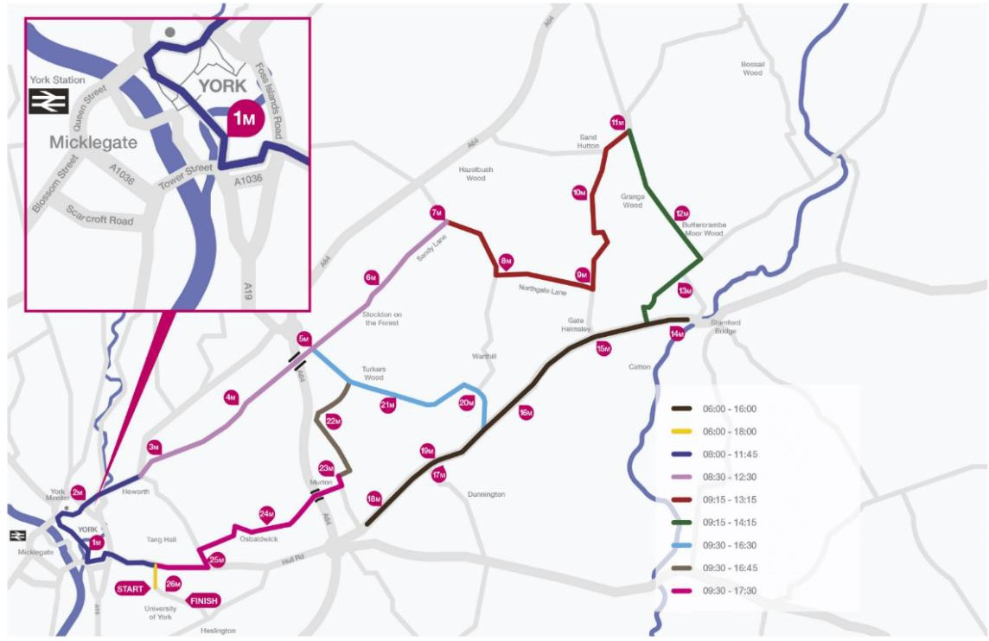


Many city centre roads and bus stops will be closed during the event. Most bus services will be on diversion, with delays expected on all routes.

For more information, please see
www.itravelyork.info, call 01904 551400 or email buses@york.gov.uk.

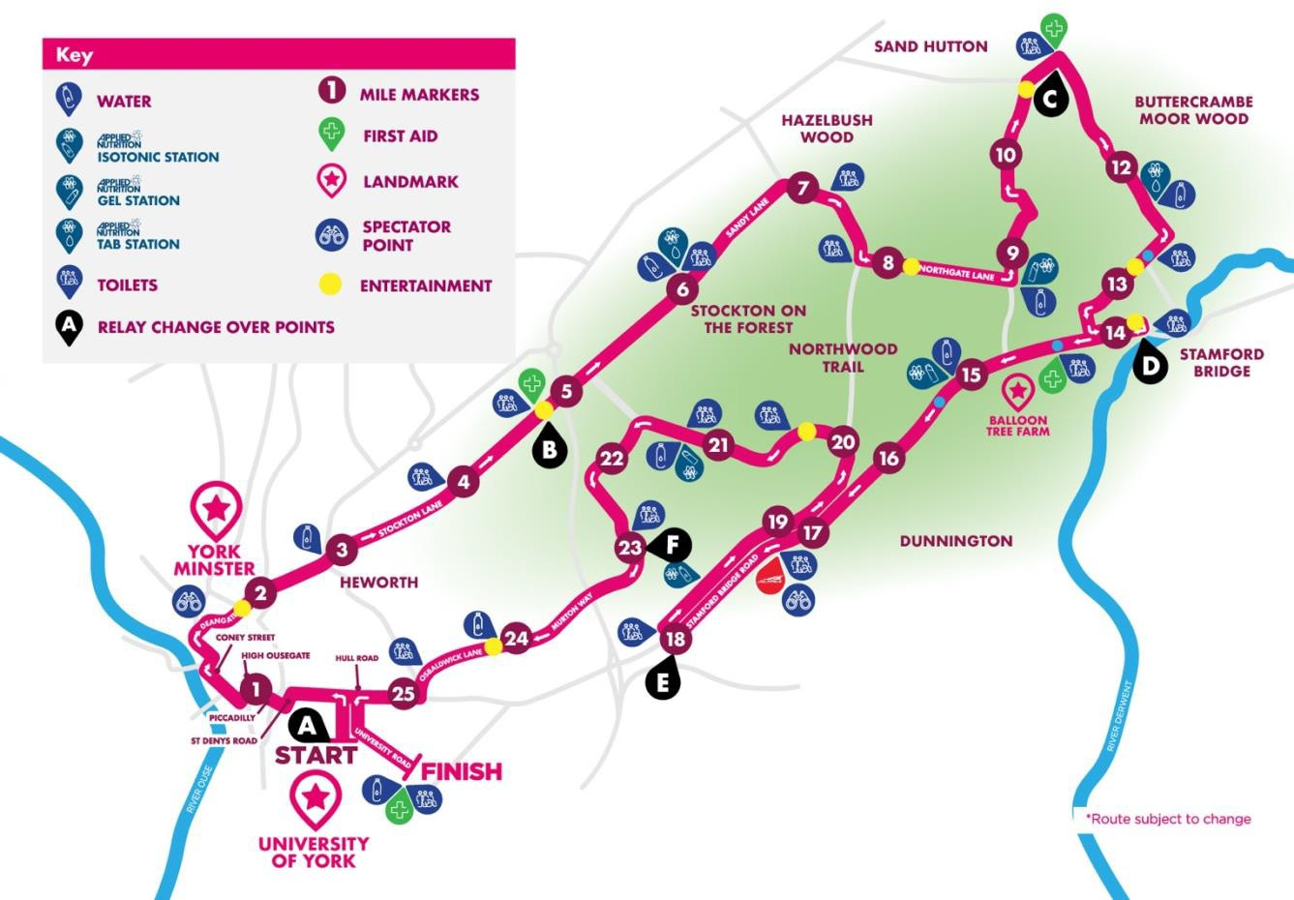

THANK YOU FOR YOUR CONTINUED SUPPORT OF THE YORKSHIRE MARATHON FESTIVAL IF YOU HAVE ANY QUERIES OR WOULD LIKE FURTHER INFORMATION PLEASE VISIT
https://www.runforall.com/road-closure-information/

